HFS Sales Agent User Manual

# Introduction:

Welcome to Halal Foods Services (HFS) sales agent portal - your all in one platform to manage your sales activities efficiently. This intuitive web application is designed specifically for sales agents, giving you quick access to your personal profile, customer list, sales targets, and daily tasks.  
On this portal you can:

* View and edit your profile information
* Access and manage your customers
* Monitor your sales target
* Create and send quotations to the clients
* Handle order placement directly from the platform
* Access your call logs
* View sales recommendations and insights

This manual will walk you through each feature to help you make the most of your experience.

# View and Edit Your Profile:

As you login to the sales agent portal you are immediately directed to your profile dashboard as shown in fig 1. This section displays your personal and account related information.

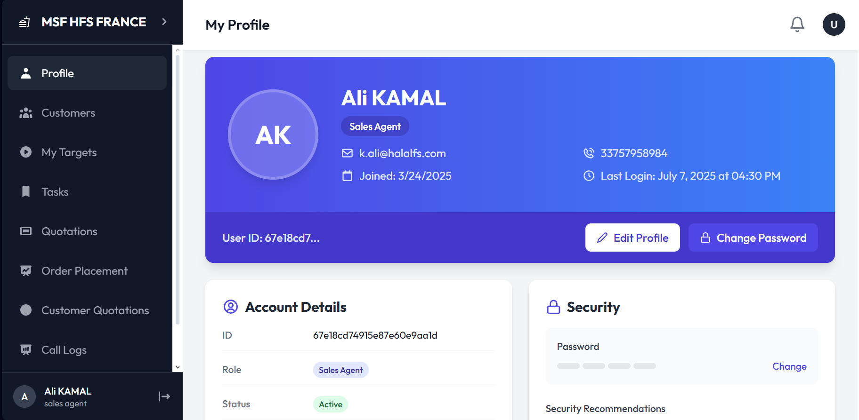

Fig 1. My profile dashboard

## **View Profile:**

You will see the following details on the **account details** section of your **profile** as shown in Fig 2**:**

* Name
* Designation
* Email
* Phone Number
* Joining date
* Last login
* User ID

This information helps you verify and manage your account details

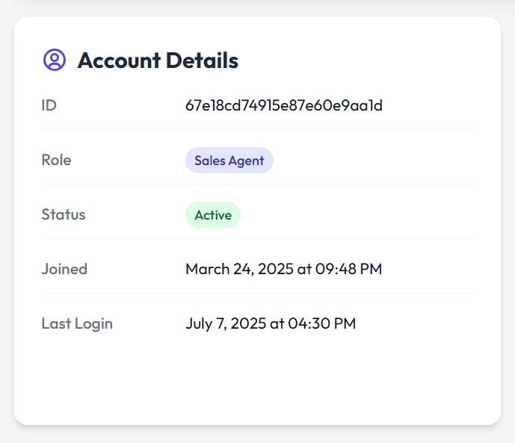

Fig 2. Sales Agent account details on the profile

## Edit Profile:

You can also update your profile details by clicking on the **edit profile** button as shown in Fig 3.

Fig 3. Editing the profile of a sales agent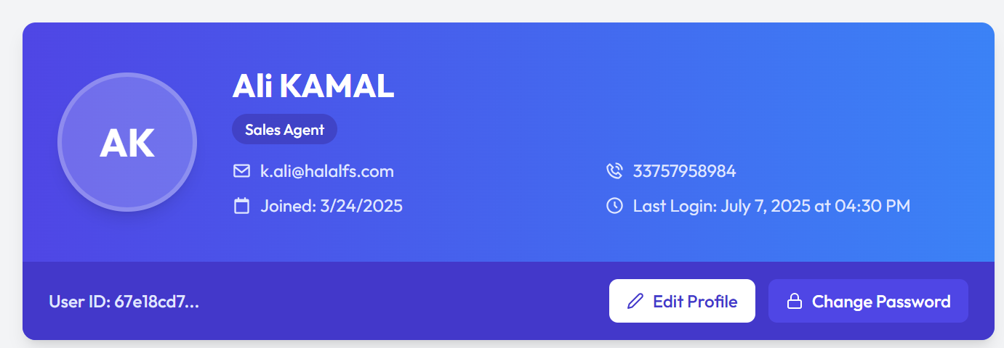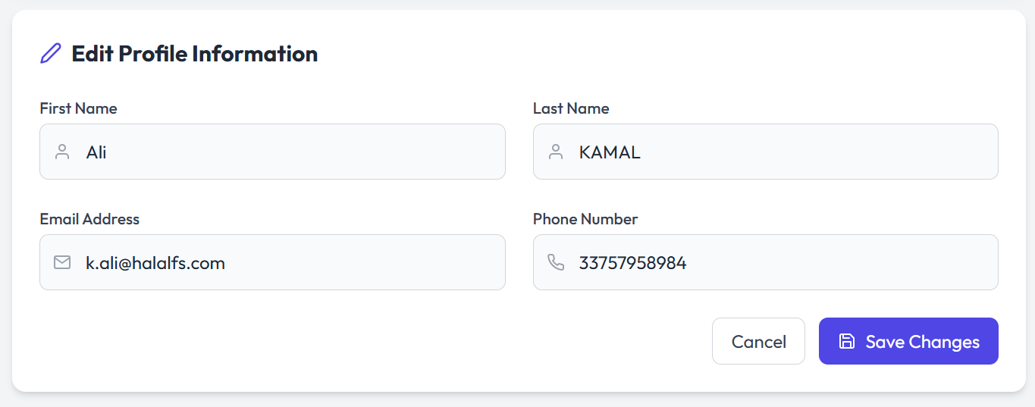

You can edit the following things on your profile:

* Name
* Phone number
* Email

## Changing Your Password:

To change your password you click on the **change password** button on your profile as shown in Fig 3 and follow the following steps:

* Enter current password
* Enter and confirm new password
* Click the **update password** button
* You can also click cancel if you do not want to change the password

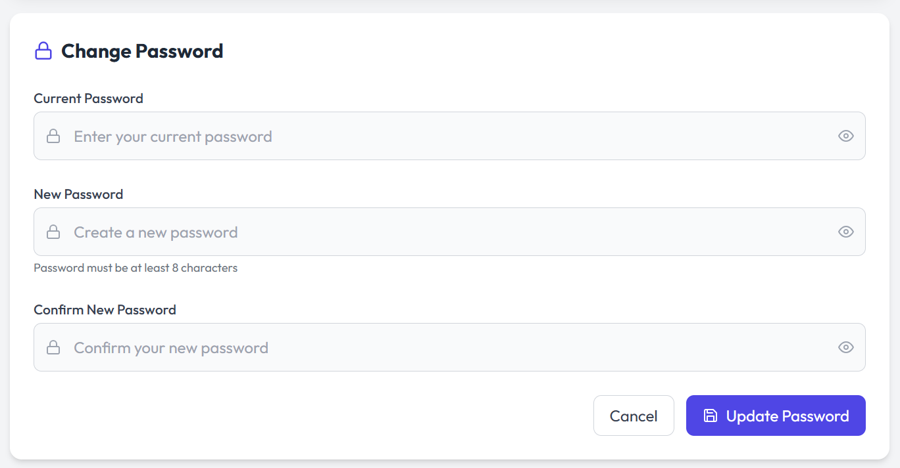

Fig 4. Changing password on sales agent profile

As you scroll to the bottom of the profile page you see a **logout** button on the bottom right. You can log out by clicking that.

# Access and manage your customers:

You can shift to the customers page by clicking on the **customers** button on the left panel on the screen as shown in Fig 1. Once you switch the screen you land on the **manage customers** screen as shown in Fig 5.

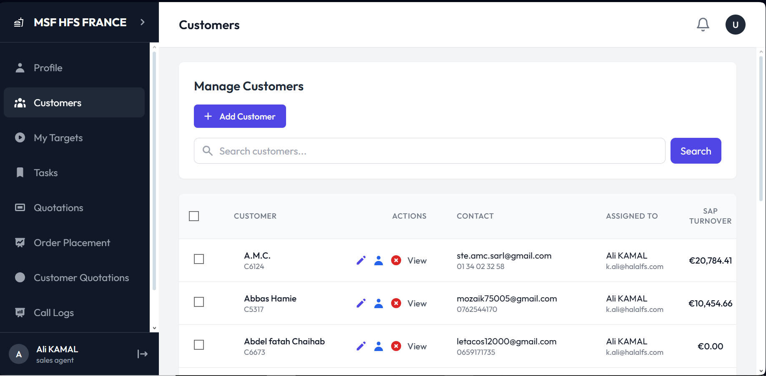

Fig 5. Customer management dashboard

## Add a New Customer:

You can add a new customer to your dashboard by clicking on the **add customer** button on the customer management dashboard as shown in Fig 5. To add a new customer:

* Click the add customer button
* Fill out the basic information form shown in Fig 6

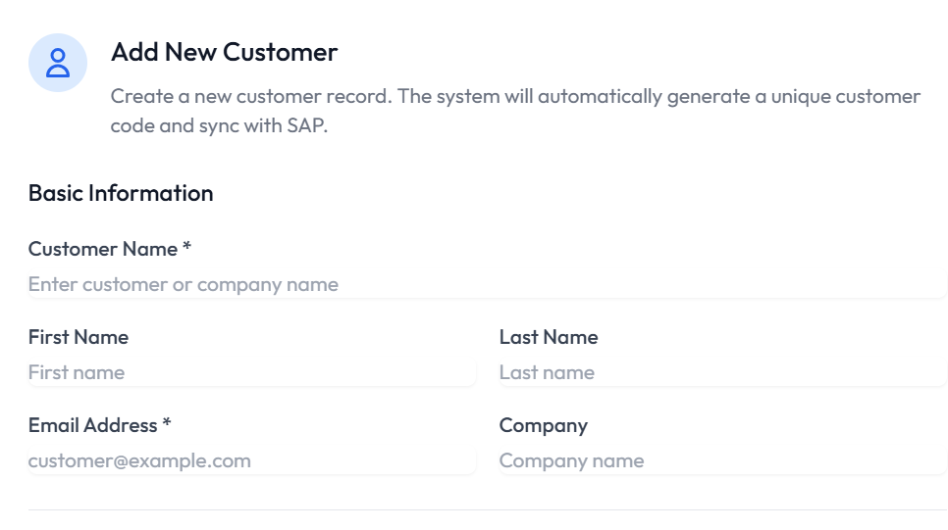

Fig 6. Basic information form on add new customer page

* Fill out the address form shown in Fig 7

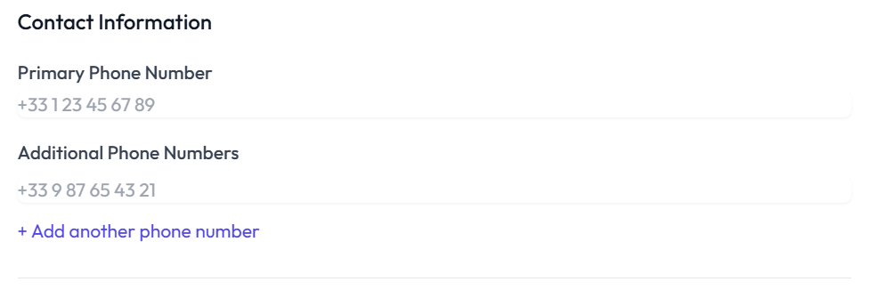

Fig 7. Contact information form on add new customer page

* Mark the status Fig 8
* Add additional notes if you want to Fig 8
* Click **create customer** button as shown in Fig 8

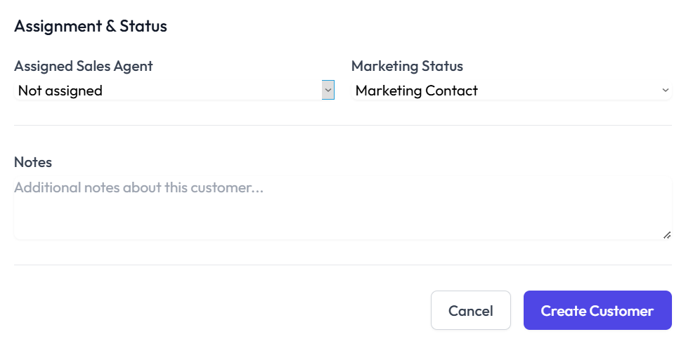  
   
Fig 8. Assignment and Statues, Notes and Create Customer button on the create new customer page

## Search a Customer:

You can search for a customer by writing their name in the search box at the top of the customers screen and pressing the **search** button as shown in Fig 5.

## Viewing Customer Details:

You can view the customer screen as shown in Fig 5. You can view the following details:

* Customer/Company name
* Actions
* Contact
* Assigned to
* SAP turnover
* Sales order total
* Last invoice
* Invoices
* Orders
* Quotations
* Abandoned carts
* Status

## Managing Customer Information:

You can manage customer information by going over to the **actions** column on the customer dashboard and clicking on the **edit** button as shown in Fig 9. You can edit the following details:

* Customer name
* Customer code
* Email address
* Phone Number

Click on the **Update Customer** button to update the information and **cancel** button to cancel the changes. You can see in Fig 10 the detailed form of customer update.

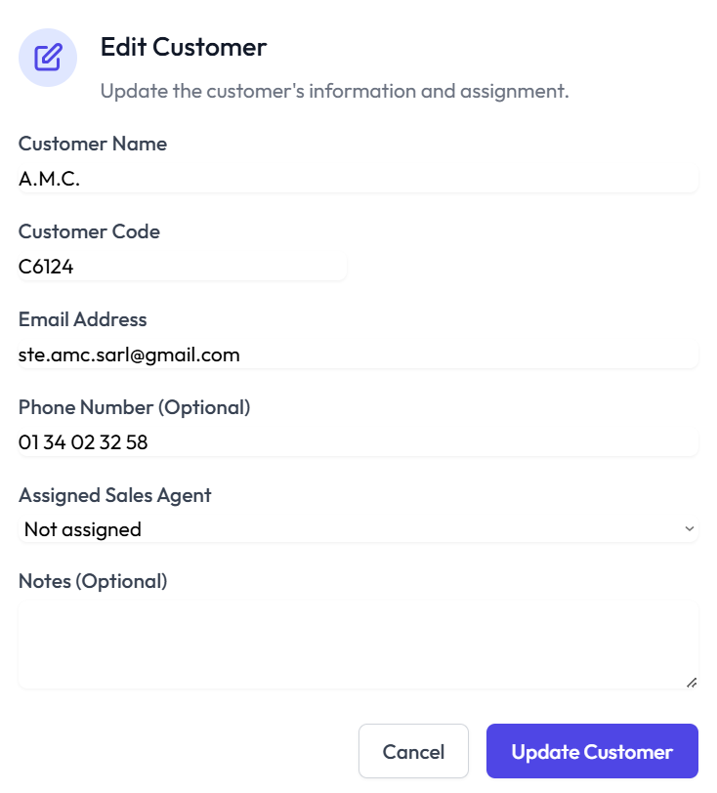

Fig 10. Edit customer form

## View Customer Journey:

You can view customer journeys by clicking on the **view** button on the actions column on the customer dashboard as shown in Fig 5. You can view a detailed report of each customer by clicking on their view button as shown in Fig 11 and Fig 12.

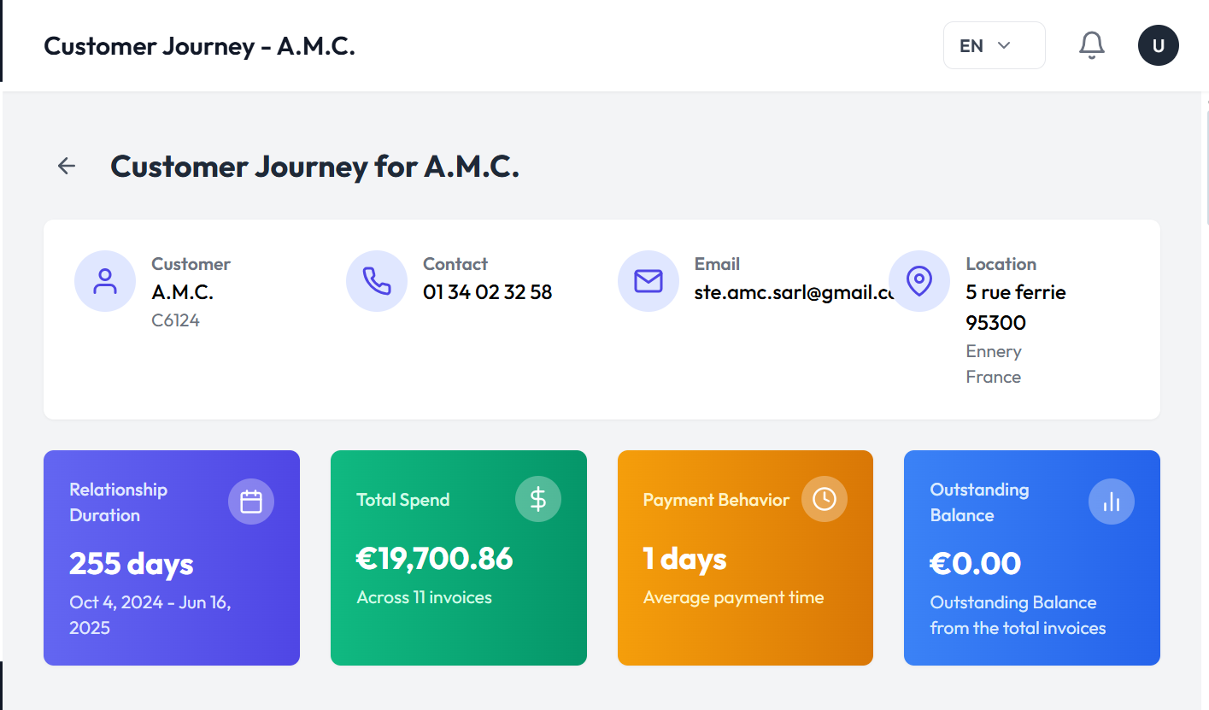

Fig 11. Customer Journey Dashboard

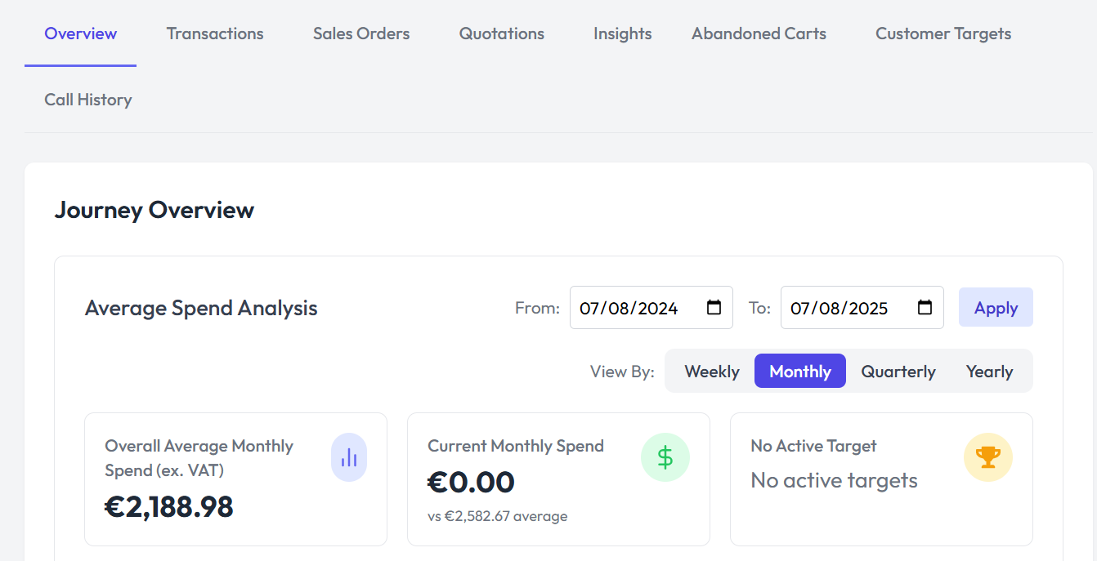

Fig 12. Customer Journey Dashboard

# Monitor Your Sales Target:

The my targets section as shown in Fig 13 helps you track your progress and stay on top of your sales goals. You can view real-time updates on the targets you've set, their current status, and details about your achievements.

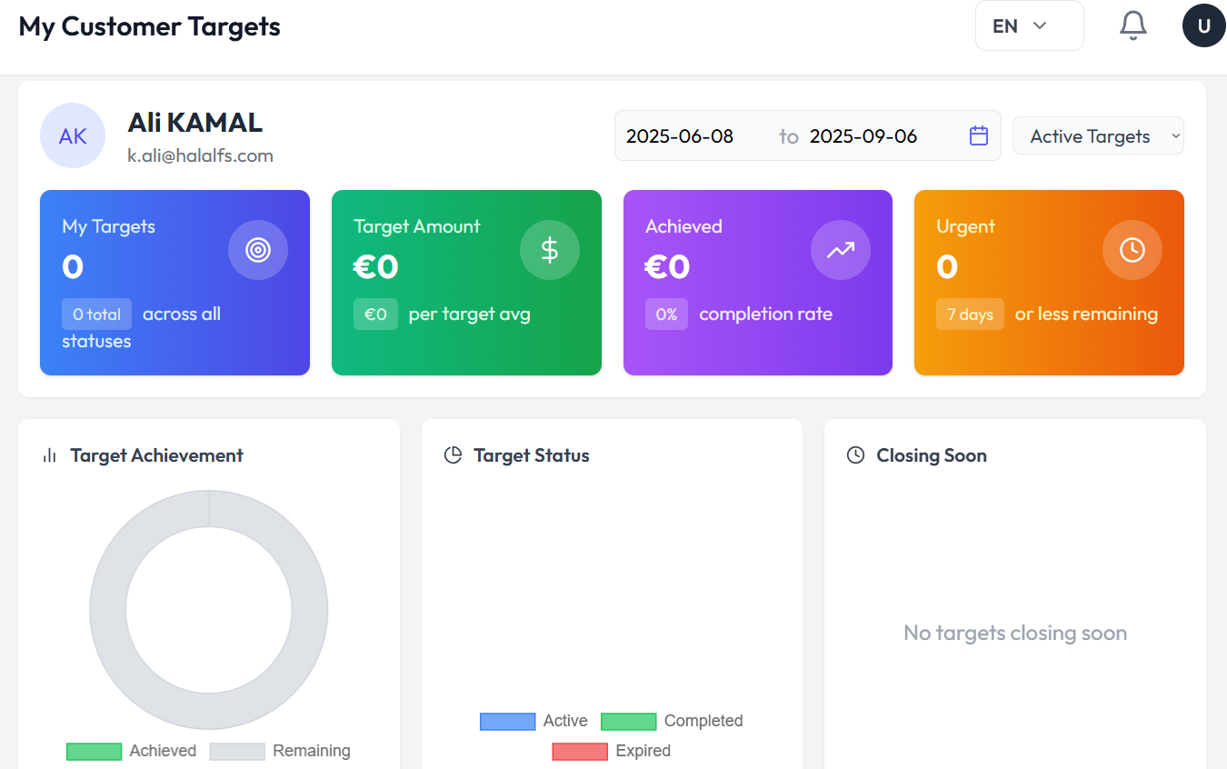

Fig 13. Sales Target dashboard of sales agents

# Create and Manage Tasks:

The tasks section helps you stay organized and focused on your daily sales activities. It allows you to create, track, and manage your tasks to ensure you meet your goals efficiently. You can view the Pending, Awaiting approval and completed tasks here.

## 

Fig 14. Task Board

## Creating a New Task:

You can create a new task by clicking on the **new task** button on the Tasks screen as shown in Fig 14. Fill out the information in the form as shown in Fig 15. The information to be filled is:

* Title
* Description
* Priority
* Type
* Due Date

Click on the **create task** button to create a new task and **cancel** button to exit the screen as shown in Fig 15.

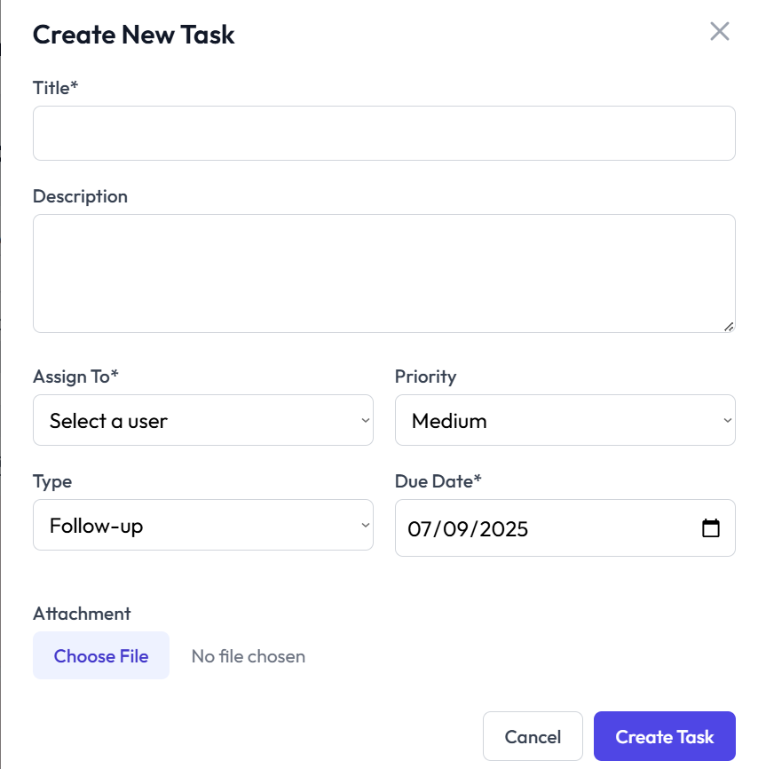

Fig 15. Create new task form

## Create New Lead:

You can also create a new lead by clicking on the **new lead** button on the task screen as shown in Fig 14. Fill out the information in the form, as shown in Fig 16 , such as:

* Full name
* Email
* Phone number
* Company
* Status
* Tags
* Notes

Click on the create lead button to create a new lead or cancel button to exit the form.

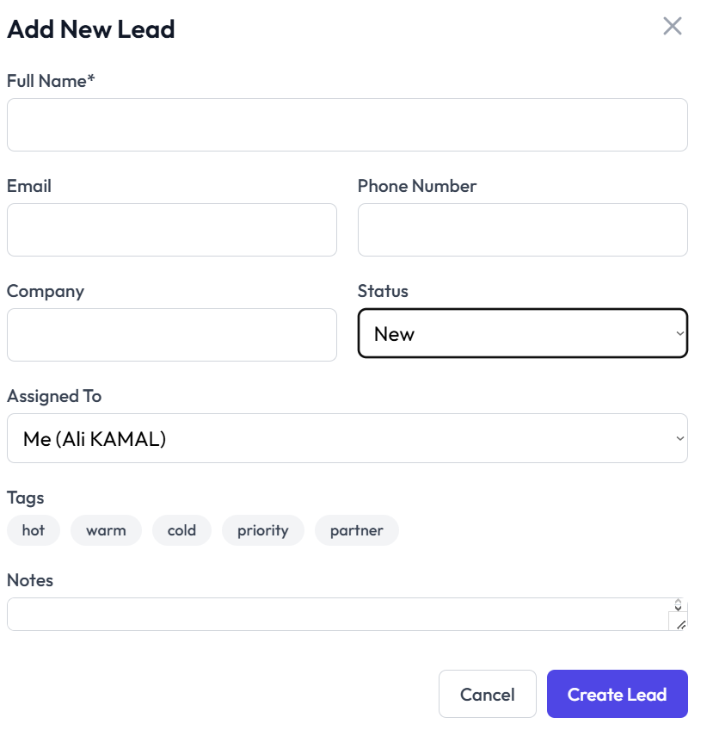

Fig 16. Add new lead form

# Creating and Managing Quotations:

The quotations section allows you to generate, customize and send quotations directly from the web app to the customers. This feature streamlines your sales process and ensures your clients receive accurate and timely quotes.

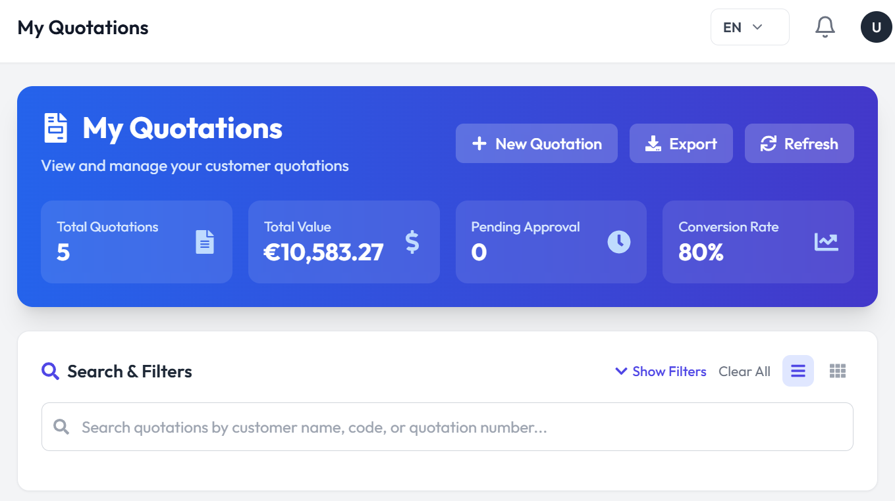

Fig 17. Quotations dashboard

You can perform the following steps on this screen:

* Creating a new quotation by clicking on the **new quotation** button on the dashboard as shown in Fig 17.
* Exporting the quotations by clicking on the **export** button on the top of the dashboard as shown in Fig 17.
* Refresh the screen by clicking on the **refresh** button on the top right of the screen as shown in Fig 17.

# Handle Order Placement:

The Order Placement feature enables you to efficiently manage customer orders, ensuring a smooth transition from quotation to order fulfillment. This section provides the tools you need to create, process, and track orders directly from the web app.

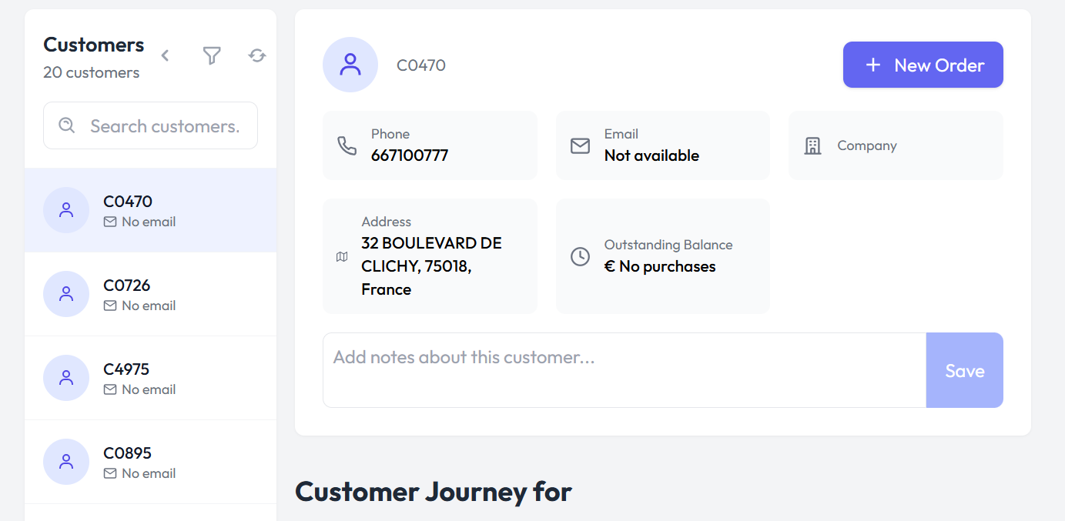

Fig 18. Customer order dashboard

## Create New Order:

You can create new orders by following the steps:

* Select a customer on the customer list present on the left side of the screen as shown in Fig 18.
* After selecting a customer click on the **new order** button on the top right of the screen as shown in Fig 18.
* Fill the form shown in Fig 19.

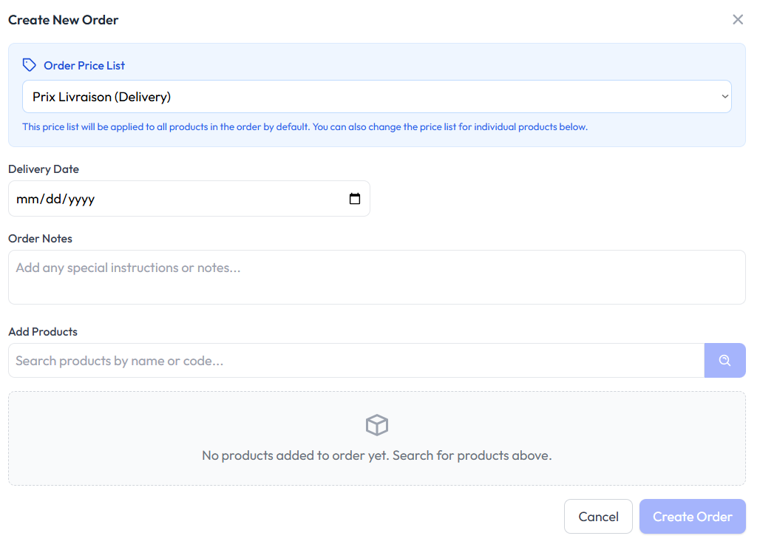

Fig 19. New order form

* Click on the create **order** button to confirm the order.

# 

# View Call Logs:

You can also view your call logs by clicking on the **call logs** tab on the left panel of the screen. Here you will see an overview of:

* Total calls
* Answer rate
* Average duration
* In / out ratio
* Daily call trend
* Call distribution

You can see all this in Fig 20.

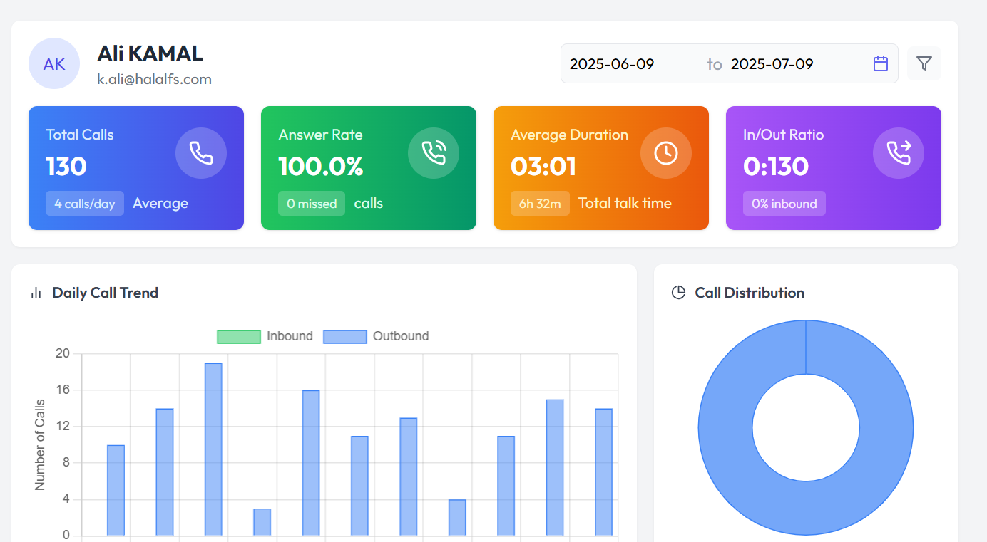

Fig 20. Call log

# 

# Recommendations:

You can view data driven sales recommendations and insights in the recommendations tab. Here you will have a view of:

* Business insights
* Key business facts
* Monthly sales trends
* Sales opportunities

You can refer to Fig 21, 22 and 23 for a better understanding.

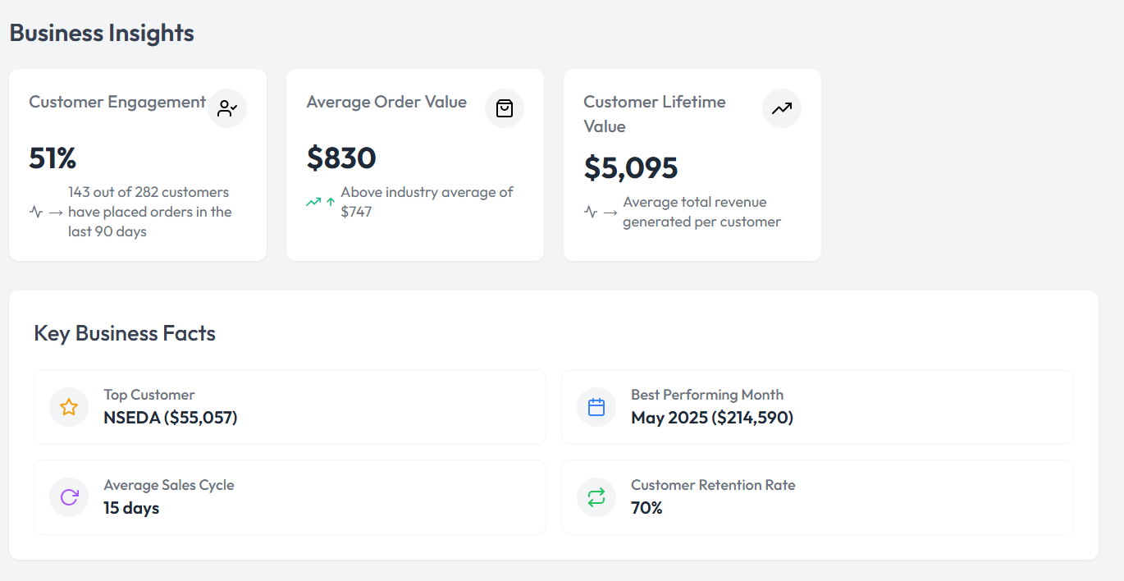

Fig 21. Business insights and Key business factors on recommendations tab

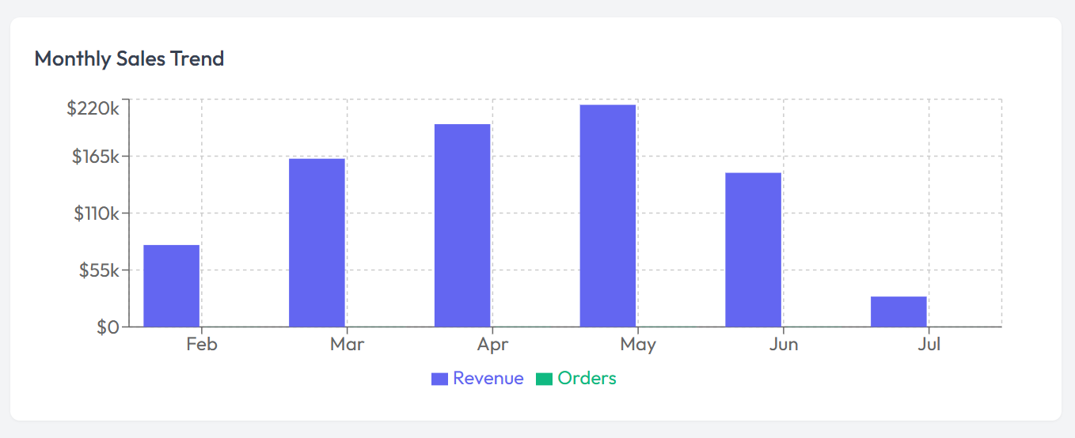

Fig 22. Monthly sales trend on recommendations tab

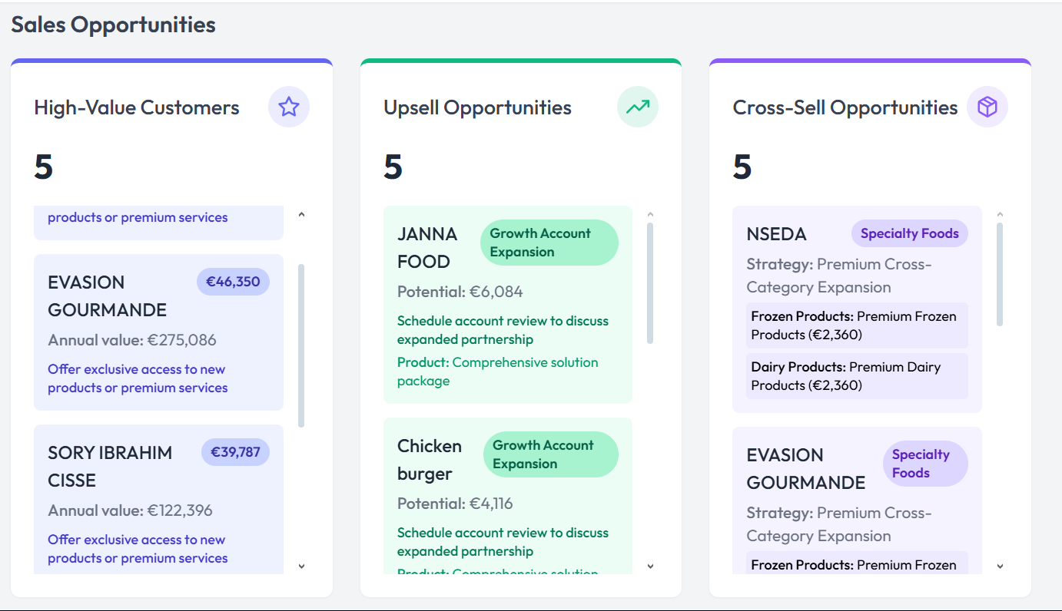

Fig 23. Sales opportunities one recommendations tab